PHYS 212 PreLab 3 Name ______________ ID_____________________
1[8’] Which of the four circuits in Figure 1 are the same electrically? Explain your answers. (Note that the circuit elements resembling a circle with a curved wire inside are light bulbs.)
___________________________________________________________
___________________________________________________________
___________________________________________________________
___________________________________________________________
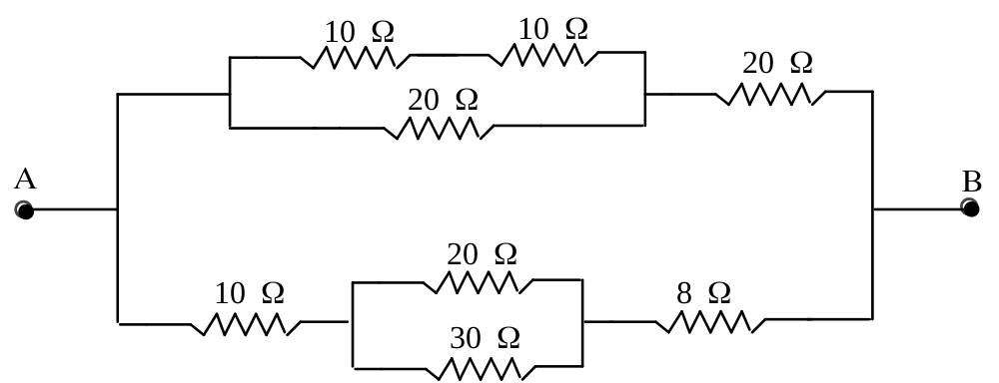
Figure 2. A resistor network
Q2[2’] What is the equivalent resistance of the network in Figure 2 between points A and B? Show your work below.

RAB = ______________ [Ω]
You are going to examine the characteristics of voltmeters and ammeters (current meters).
Q3[5’] Indicate on the circuit diagram in Figure 2 how you would connect an ammeter to measure the current through the 8-Ω resistor. Why is the ammeter connected in this way?
___________________________________________________________
___________________________________________________________
___________________________________________________________
Q4[5’] What is it about the design of a good ammeter that allows you to connect it in the way indicated above without appreciably affecting the current through the 8-Ω resistor?
___________________________________________________________
___________________________________________________________
___________________________________________________________
Q5[5’] Indicate on the circuit diagram in Figure 2 how you would connect a voltmeter to measure the voltage across the 8-Ω resistor. Why is the voltmeter connected in this way?
___________________________________________________________
___________________________________________________________
Q6[5’] What is it about the design of a good voltmeter that allows you to connect it in the way indicated above without appreciably affecting the voltage across the 8-Ω resistor?
___________________________________________________________
___________________________________________________________

Q7[8’]
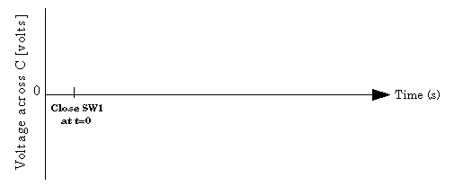
Q8[5’] If the resistance is cut in half, will the time for the voltage across the capacitor to fall to V₀/2 change? If so, how will it change?
___________________________________________________________
___________________________________________________________
___________________________________________________________
Q9[5’] If the capacitor's capacitance is doubled (instead of halving the resistance), will the time for the voltage across the capacitor to fall to V₀/2 change? If so, how will it change?
___________________________________________________________
___________________________________________________________
___________________________________________________________

Q10[2’] Your lab partner tells you that his measured resistance was higher than his prediction by 1.3 Ω. Since this claim is meaningless by itself, you ask him what he actually measured. He says 10.1 Ω. What is the percentage difference %Δ between the measured value and theoretical prediction?
__________________________________________________________
__________________________________________________________
__________________________________________________________

